**RISC-V Reference SoC Tapeout Program (VSD)**

**Tools Installation Guide:**

**This guide covers installation of the essential open-source tools for the VSD program.**

**----------------------------------**

**System Requirements**

**RAM: 6 GB**

**Storage: 50 GB HDD**

**OS: Ubuntu 20.04 or higher**

**CPU: 4 vCPU**

**----------------------------**

**Step 1: Ubuntu Setup**

**I resized the Ubuntu window to fit my screen.**

**Updated system and installed essential build headers:**

**sudo apt update**

**sudo apt install build-essential dkms linux-headers-$(uname -r)**

**Installed VirtualBox Guest Additions:**

**cd /media/spatha/VBox_GAs_7.1.8/**

**sudo ./autorun.sh**

**-----------------------**

**Step 2: Tool Installation**

**1. Yosys (Synthesis Tool)**

**sudo apt-get update**

**git clone https://github.com/YosysHQ/yosys.git**

**cd yosys**

**# Installed dependencies**

**sudo apt install make**

**sudo apt-get install build-essential clang bison flex \**

**libreadline-dev gawk tcl-dev libffi-dev git \**

**graphviz xdot pkg-config python3 libboost-system-dev \**

**libboost-python-dev libboost-filesystem-dev zlib1g-dev**

**# Configured and initialized submodules**

**make config-gcc**

**git submodule update --init --recursive**

**# Built and installed**

**make**

**sudo make install**

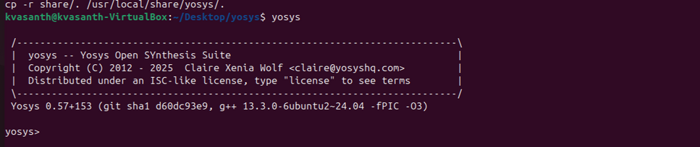

**----------------------------------**

**2. Icarus Verilog (iverilog)**

**sudo apt-get update**

**sudo apt-get install iverilog**

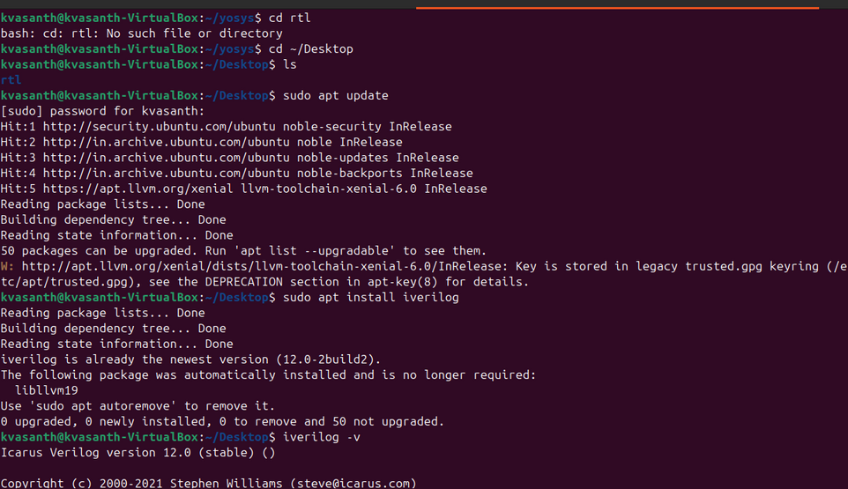

**---**

**3. GTKWave (Waveform Viewer)**

**sudo apt-get update**

**sudo apt install gtkwave**

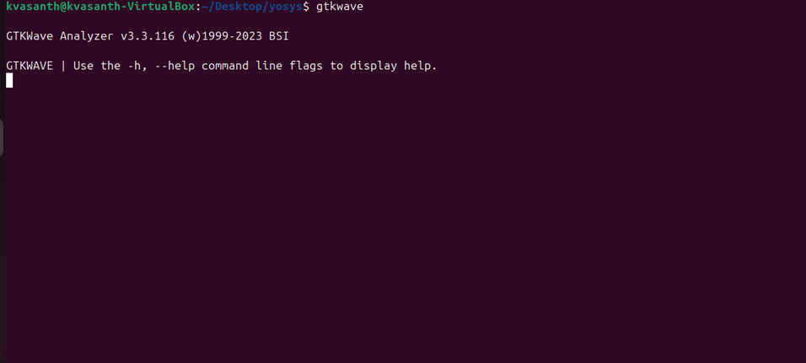

**-----------------------------**

**✅ All tools have been successfully installed and are ready for use in the VSD program.**